# Exercise 1:

## Q1

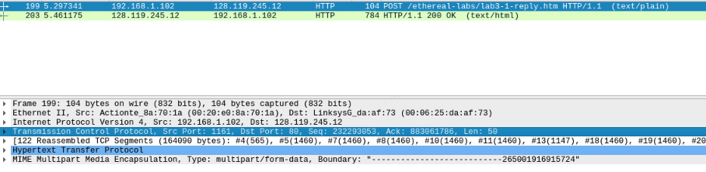

The IP address of ‘gaia.cs.umass.edu’ is 192.168.1.102. It sending and receiving TCP segments for this connection in the port number 80.

the IP address and TCP port numbers used by the client computer (source) that is transferring the file to gaia.cs.umass.edu is 192.168.1.102, 1161.

## Q2

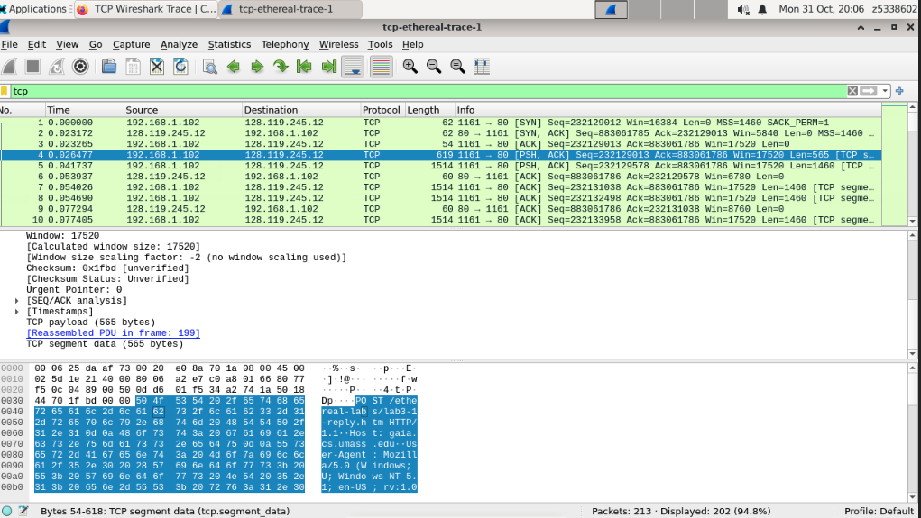

As the chart, the sequence number of the TCP segment containing the HTTP POST command is 232129013.

## Q3



## Q4.

As the chart in the Q3 has e length of each of the first six TCP segments.

## Q5.

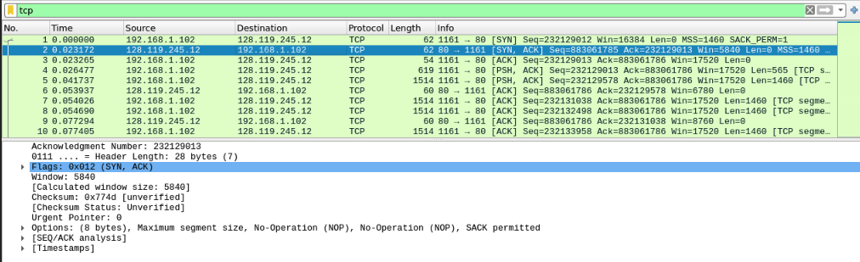

As the chart, the minimum amount of available buffer space advertised at the receiver for the entire trace is 5840. The lack of receiver buffer space will throttle the sender.

## Q6.

Because the sequence numbers tend to increase, there are no retransmissions.

## Q7.

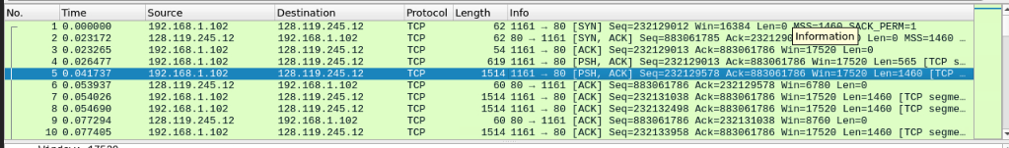

About 1460 bits data does the receiver typically acknowledge in an ACK.

## Q8.





The throughput=(232293103-232129013)/1000/(5.45583-0.026477)=30.223kbit/s

# Exercise2

## Q1.



The sequence is 2818463618.

## Q2.



The reply sequence is 1247095790, the value of the Acknowledgement field in the SYNACK segment is 1460.

## Q3.



the sequence number of the ACK segment sent by the client computer in response to the SYNACK is 2818463619. The value of the Acknowledgment field in this ACK segment is 1247095791. The segment contain 1 bit data.

## Q4.

Both client and server done the active close since the connect close only need one (FIN,ACK/ACK), but it has two. So the client and server are close at the same time. This is a 4 Segment of Simultaneous close.

## Q5.

There are (2818463652-2818463618)=34bit=4.25bytes data transferred from the client to the server and (1247095831-1247095790)=41bit=5.125bytes from the server to the client during the whole duration of the connection.

the final ACK received from the other side minus Initial Sequence Number can get the data during the transferred.